UNIT - 1

NATURE AND SIGNIFICANCE OF
MANAGEMENT

Management is an art of getting things done through others. Management can be defined as, the process of getting things done with the aim of achieving goals effectively and efficiently.

Efficiency and Effectiveness
Efficiency means doing the task correctly at minimum cost while effectiveness means completing the task correctly. Although Efficiency and effectiveness are different but they are interrelated. It is important for management to be both i.e. effective and efficient.
Example : A business produces targeted 1000 units but at a higher cost is effecitive but not efficient. Therefore if the business has to be effective and efficient then it has to produce 1000 units within cost.

Characteristics of Management
- Goal oriented Process : It is a goal oriented process, which is undertaken to achieve already specified and desired objectives.
- Pervasive : Management is pervasive in nature. It is used in all types of organizations whether economic, social or political and at every level.
- Multidimensional : It is multidimensional as it involves management of Work, People and operations.
- Continuous : It is a continuous process i.e. its functions are being performed by all managers simultaneously. The process of management continue till an organisation exist for attaining its objectives.
- Group Activity : It is a group activity since it involves managing and coordinating activities of different people as a team to attain the desired objectives.
- Dynamic function : it is a dynamic function since it has to adapt to the changing environment.
- Intangible Force : It is an intagible force as it cannot be seen but its effect are felt in the form of results like whether the objectives are met and whether people are motivated or not.

Objectives of management
- Organizational objectives of Survival (Earning enough revenues to cover cost); Profit (To Cover cost and risk); & Growth (To improve its future Prospects).
- Social Objectives of giving benefits to society like using environmental friendly practices and giving employment to disadvantaged sections of society etc.
- Personal Objectives because diverse personal objectives of people working in the organization have to be reconciled with organizational objectives. Importance of management
- Achieving Group Goals : Management helps in achieving group goals. Manager give common direction to the individual effort in achieving the overall goal of the organisation.
- Increases Efficiency : Management increases efficiency by using resources in the best possible manner to reduce cost and increase productivity.
- Creates Dynamic Organisation : Management helps in creating Dynamic organisation which could adopt changing situations easily.
- Achieving Personal Objectives : Management helps in achieving objectives of individuals working in the organisation.
- Development of Society : Management helps in the development of society by producing good quality products, creating employment opportunities and adopting new technology.

Management as an Art
Art refers to skillful and personal application of existing knowledge to achieve desired results. It can be acquired through study, observation and experience. The features of art are as follows.
(2) Existence of theoretical knowledge : In every art systematic & organised study material should be available compulsorily to acquire theoretical knowledge.

- Personalised application : The use of basic knowledge differ from person to person and thus, art is a very personalised concept.
- Based on practice and creativity : Art involves the creative practice of existing theoretical knowledge.
All the features of art are present in management so it can be called an art.

Management as a science
Science is a systematised body of knowledge that is based on general truths which can be tested anywhere, anytime. The features of science are as follows
- Systematized body of knowledge : Science has a systematised body of knowledge based on principles and experiments.
- Principles based on experiments & observation : Scientific principles are developed through experiments and observations.
- Universal Validity : Scientific principles have universal validity and application. Management has systematic body of knowledge and its principles are developed over a period of time based on repeated experiments & observation, which are universally applicable.
As the principles of management are not as exact as the principles of pure science, so it may be called inexact science.
Management as a profession :
Profession means an occupation for which specialised knowledge and skills are required. The main features of profession are as follows.
- Well defined body of knowledge : All the professions are based on well defined body of knowledge.
- Restricted entry : The entry in every profession is restricted through examination or through some minimum educational qualification.
- Professional Associations : All professions are affiliated to a professional association which regulates entry and frame code of conduct relating to the profession.
- Ethical code of conduct : All professions are bound by a code of conduct which guides the behaviour of its members
- Service Motive : The main aim of a profession is to serve its clients.
Management does not fulfill all the features of a profession and thus it is not a full pledged profession.

Levels of Management : Top, Middle and operational levels.

Top Level
Consists of Chairperson, Chief Executive Officer, Chief Operating Officer or equivalent and their team.
Chief task is to integrate and to coordinate the various activities of the business, framing policies, formulating organisational goals & strategies. Middle Level
Consists of divisional heads, Plant Superintendent and Operations Manager etc.
Main tasks are to interpret the policies of the top management, to ensure the availability of resources to implement Policies & to coordinate all activities, ensure availability of necessary personnel & assign duties & responsibilties to them.

Lower Level / Supervisory Level
Consists of Foremen and supervisors etc.
Main task is ensure actual implementation of the policies as per directions, bring workers grievances before the management & maintain discipline among the workers.
Functions of Management : Planning, Organizing, Staffing, Directing and Controlling.
Planning is deciding in advance what to do in future and how to do it.
Organizing is to assign duties, grouping tasks, establishing authority and allocating resources required to carry out a specific plan.
Staffing is finding the right people for the right job.
Directing is leading, influencing and motivating employees to perform the tasks assigned to them.
Controlling is monitoring the organizational performance towards the attainment of organizational goals.
Coordination : The essence of Management : Coordination is the force which synchronizes all the functions of management and activities of different departments.
It integrates the group efforts.
It ensure unity of action.

It is a continuous process.
It is an all pervasive function.
It is a deliberate function.
It is the responsibility of all managers

IMPORTANT QUESTIONS
1 Mark Questions (To be answered in one word or one sentence)
- In order to be successful an organization must change its goals according to the needs to the environment. Which characteristic of management is highlighted in the statement? (Answer: It is a dynamic function).
- To meet the objectives of the firm the Management of Angora Limited offers employment to Physically Challenged persons. Identify the organizational objective it is trying to achieve (Answer : Social Objective.
- Management of any organization strives to attain different objectives. Enumerate any two such objectives.
- Give any two characteristics of management.
- Management is multidimensional. Enumerate any two dimensions of management.
- Managerial activities are performed in all types of organizations in all departments at all levels. Which management character is highlighted here? (Answer : It is all pervasive)
- Your grandfather has retired where he is responsible for implementing the plans developed by the top management at which level of management was he working? State one more function of this level of management. (Answer: Middle level management) (Write any one function of this level).
- List any two social objectives of management.
- Your grandfather has retired as a Director of manufacturing company. At which level of management was he working? Different functions are performed at this level. State any one such function. (Answer : Top level of management) Write any one function of this level).
- What is meant by management ?

3/4 Marks Questions (To be answered in about 50 to 70 words)
- There are different Business Objectives and Economic Objectives are one among them. Explain these economic objectives.
- Explain how management is an art
- Explain why management is not considered a full fledged profession.
- Explain how management is science.
- Coordination is the essence of management . Explain.

5/6 Marks Questions (To be answered in about 150 words)
- Management is a Profession like Accounting, Medicine and Law as it also has a well defined body of knowledge. Yet management does not qualify to be a full fledged profession. Why? (Hint : No formal qualification is prescribed to enter management, no code of conduct is prescribed).
- Success of an organization largely depends upon its management Explain any five reasons to justify the statement. (Hint : Give five points of Importance of management

UNIT - 2 PRINCIPLES OF MANAGEMENT

Concept of Principle of Management :
Principle of Management are the broad and general guidelines for managerial decision making. They are different from principles of science as they deal with human behaviour. They are different from techniques of management as techniques are method whereas principles are guidelines to action and decision making. Principle of management are different from values which are formed as generally accepted behaviour in society and having moral coordination where-as principles are formed through research having teachnical nature.

Nature of Principles of Management
The nature of principles of management can be described in the following points :
- Universal applicability i.e. they can be applied in all types of organizations, business as well as non-business, small as well as large.
- General Guidelines : They are General Guidelines to action which however do not provide readymade solutions as the business environment is very changing or dynamic.
- Formed by practice and experimentation : They are developed after thorough research work on the basis of experiences of managers.
- Flexible which can be modified by the practicing manager as per the demands of the situations.
- Mainly Behavioural : Since the principles aim at influencing human behaviour they are behavioural in nature.
- Cause and Effect relationship : They intend to establish relationship between cause & effect so that they can be used in similar situations.
- Contingent : Their applicability depends upon the prevailing situation at a particular point of time.

Significance of the Principles of Management
The significance of principles of management can be derived from their utility which can be understood from the following points :
- Providing managers with useful insights into reality.
- Optimum utilization of resource and effective administration.
- Scientific decisions.
- Meeting the changing environmental requirements.
- Fulfilling social responsibility.
- Management training, education and research.
Taylor s Scientific Management :
F.W. Taylor (1856-1915) was an American mechanical engineer who believed in analyzing the work scientifically and finds one best way to do any work. His book Principles of Scientific Management was published in 1911.
Principles of Scientific Management :
Taylor gave the following principles of scientific management :
- Science and not the rule of thumb : which implies developing one standard method through work study unifying the best practices globally which would result in optimum resource utilization.
- Harmony, Not discord : which implies that there sould be mental revolution on part of managers, workers and owners to respect each other s role and eliminate any class conflict to realize organizational objectives.
- Cooperation not individualism : It is an extension of the Principle of Harmony, Not discord whereby constructive suggestions of workers should be adopted and they should not go on strike as both management and workers share responsibility and perform together. Infact there should be complete cooperation between the labour and the management instead of individualism.
- Development of Each and Every Person to His or Her greatest Efficiency and Prosperity : Which implies development of competencies of all persons of an organization after their scientific selection and assigning work suited to their temperament and abilities.

Techniques of Scientific Management
- Functional Foremanship : Functional foremanship is a technique in which planning and execution are saparated. There are 8 types of specialized professionals 4 each under planning and execution who keep a watch on all workders to extract optimum performance.
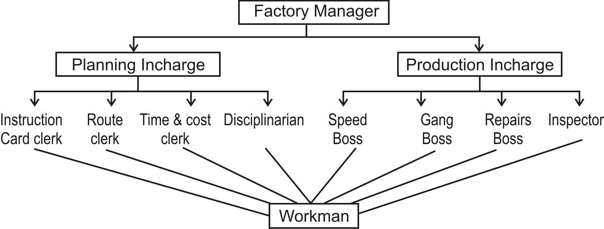
- Standardisation and Simplification of work : Standardization refers to developing standards for every business activity whereas Simplification refers to eliminating superfluous varieties of product or service. It results in savings of cost of labour, machines and tools. It leads to fuller utilization of equipment and increase in turnover.
- Method Study : The objective of method study is to final out one best way of doing the job to maximise efficiency in the use of materials, machinery, manpower and capital.
- Motion Study : Motion study seeks to eliminate unnecessary motions in the execution of a job to enable it to be completed in less time efficienty.
- Time study : It determines the standard time taken to perform a well defined job. The objective of time study is to determine the number of workers to be employed, frame suitable incentive schemes & determine labour costs.
- Fatigue study : Fatigue study seeks to determine amount and frequency or rest intervals in completing a task.
- Differential Piece Wage system : Differential Piece Wage system seeks to reward a more efficient worker by giving him/her more wages for more quantity of standard production achieved.
- Mental Revolution : It involves a change in the attitude of workers and management towards one another from competition to cooperation.
Foyol s Principles of Management : Henri Fayol (1841-1925) was a French Mechanical engineer who gave 14 general principles of Management which are as under :
- Division of Work : Work is divided into small tasks / jobs and each one is done by a trained specialist which leads to greater efficiency.
- Authority and Responsibility : Managers are empowered with authority to give orders and obtain obedience and responsible for the accomplishment of task for which they are granted authority.
- Discipline : it is the obedience to organizational rules and employment agreement which are necessary for working of the organization.
- Unity of Command : There sould be only one boss for every employee. If an employee gets orders from two superiors at the save time the principle of unity of command is voilated.
- Unity of Direction : Each group of activities having the same objective must have one head and one plan. This ensures unity of action and coordination.
- Subordination of Individual Interest to General Interest : The Interest of an organization should take priority over the interests of any one individual employee.
- Remuneration of Employees : The overall pay and compensation should be fair to both employees and the organization.
- Centralization and Decentralization : The concentration of decision making authority is called centralization whereas its dispersal among more than one person is known as decentralization. Both should be balanced.
- Scalar Chain : The formal lines of authority between superiors and subordinates from the highest to the lowest ranks is known as scalar chain. This chain should not be voilated but in emergency employees at same level can contact through Gang Plank.
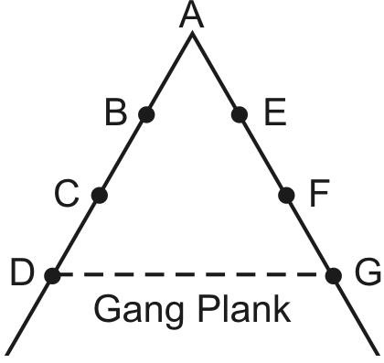
- Order : A place for everything (everyone) and everything (everyone) in its place. People & materials must be in suitable places at oppropriate time for maximum efficiency.
- Equity : The working environment of any organization should be free from all form of discrimination and the principles of Justice and fair play should be followed.
- Stability of Personnel : After being selected and appointed after due and rigorous procedure the selected person should be kept at the post for a minimum period decided to show result.
- Initiative : Workers should be encouraged to develop and carry out their plans for improvements. Initiative means taking the first step with self motivation It is thinking out and executing the plan.
- Espirit De Corps : Management should promote team spirit, unity and harmony among employees. Management should promote a team work.
Difference between unity of command and unity of direction
Basis Unity of Command Unity of Direction
(2) Meaning One subordinate should Each group of activities
receive orders from & having save objectives should be responsible must have one head and to only one superior. one plan
- Aim Prevents dual Prevents overlapping of subordination activities
- Implications Affects an individual Affects the entire
employee organisation.
Fayol versus Taylor :
While the work of Taylor concerned shop floor, the work of Fayol concerned General Principles applicable to all types of situations.

IMPORTANT QUESTIONS
1 Mark Questions (To be answered in 1 word or 1 sentence)
- The Principles of Management are different from those used in pure science". Write anyone difference.
- Why is it said that the management principles are universal?

- Different techniques were developed by Taylor to facilitate the Principles of Scientific Management. One of them was 'Fatigue study'. What is the
objective of this study?
- List any two principles of "Scientific Management" formulated by Taylor for managing an organization scientifically?
- What is meant by principles of management?
- State anyone principle of scientific management.
- State any one reason why Principles of Management are important.
- Give the meaning of mental revolution as suggested by Taylor.
3/4 MARKS QUESTIONS :
- Explain the following principles of management:-
  - Equity.
  - Remuneration of Employees.
- In your school, you observe that books, are kept in office, chalks in the library and office records in the staffroom. How will that affect the achievement of school objectives? Which aspect of management is lacking and why? As a manager, what steps will you take to rectify the shortcomings?
5/6 Marks Question (to be answered in about 150 words)
- Explain any two techniques of Taylor s Scientific Management.
- Explain the following principles of Fayol with example.
  - Unity of Command
  - Unity of Direction
  - Order
  - Espirit De Corps.

